**Project Design Phase-I**

**Solution Architecture**

|  |  |
| --- | --- |
| DATE | 01/10/2022 |
| TEAM ID | PNT2022TMID23570 |
| PROJECT NAME | Analytics for Hospital Healthcare Data |
| MAXIMUM MARKS | 4 Marks |

**Solution Architecture:** Solution architecture is a complex process – with many sub-processes – that bridges the gap between business problems and technology solutions. Its goals are to:

● Find the best tech solution to solve existing business problems.

● Describe the structure, characteristics, behavior, and other aspects of the software to project stakeholders.

● Define features, development phases, and solution requirements.

● Provide specifications according to which the solution is defined, managed, and delivered.

**Data Transformation**



**Data Storage**

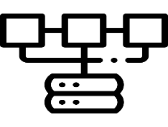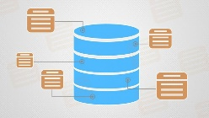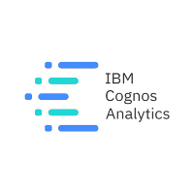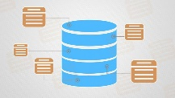

**Architecture and data flow of the Hospital Healthcare data using data analytics**

Dashboard

**Visualization**

Cloud storage

**Meta Data**

Database

Python

IBM Cognos

Algorithm

Literature survey

Staff requirement

Collecting user information

Database